These instructions come courtesy of Matthew Carlone at SAU 8 in Concord.

The plugin is called MBA Custom Alerts by Marcia Brenner Associates. Here’s the link to the plugin: [https://mba-link.com/customizations](https://protect-us.mimecast.com/s/pm9dClYMzQhkVJ8tGZ_lG?domain=mba-link.com). I don’t know what the pricing is, but I don’t think it’s much.

The plugin let us create an alert that appears when a staff or teacher views a student in PowerSchool who has an IEP or a 504 plan. The alert will appear at the top of the screen with all of the other alerts. When a teacher/staff member clicks the alert, it presents a text box pop-up that lists the student’s case manager and includes a link directly to the student’s documents in the SP library.

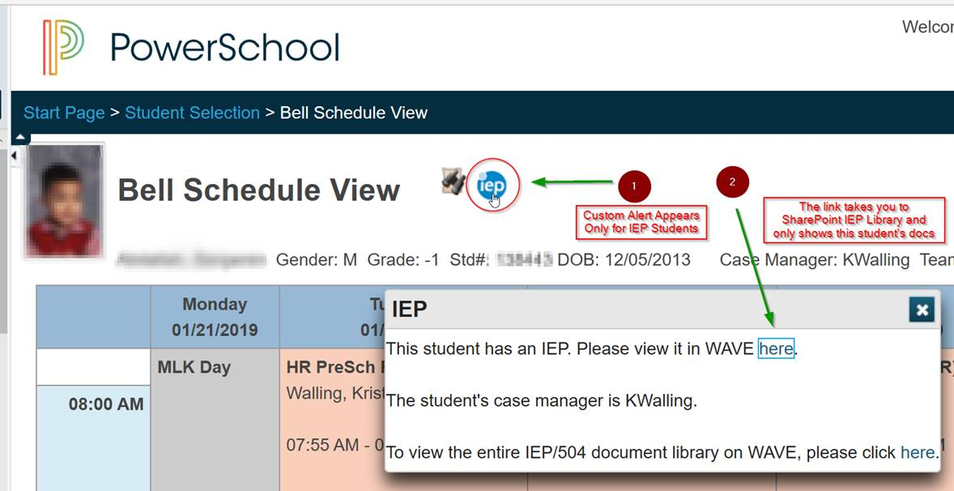

The plugin is easy to set up. Here’s a screenshot for our IEP alert:

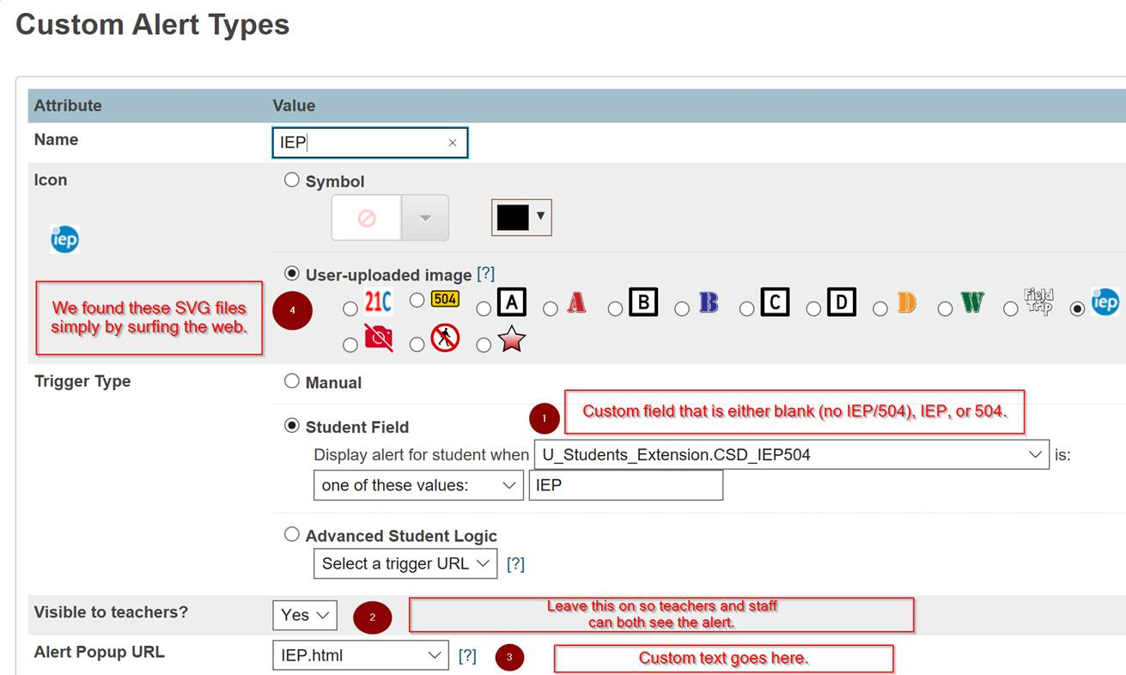

The alert popup URL was a little tricky to set up, but anyone can feel free to use our info as a basis. The coolest part of this popup is how we linked to the specific student’s IEP documents in the library: all we did was create a search string for the student’s ID number. Because staff/teachers will only get results for students they have access to, there’s no concern that the search will capture other student’s documents. And, it will find *all* documents related to the student, meaning that there can be additional documents for the student, such as case notes or draft/revised plans. Here’s a screenshot of our setup:

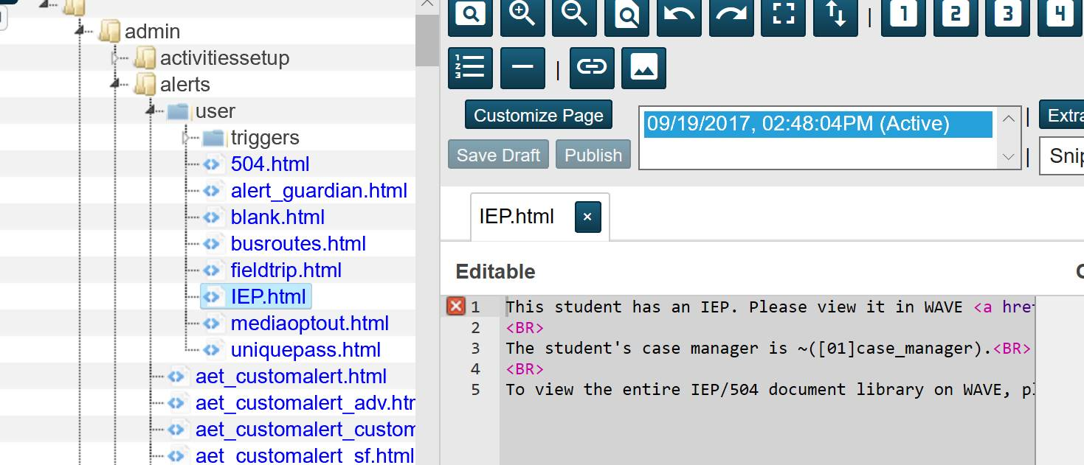

D’oh! That’s not very helpful. Here’s the text from the window above:

This student has an IEP. Please view it in WAVE <a href="[https://sau8.sharepoint.com/sites/StudentServices/Documents/Forms/Default.aspx?view=7&q=~([01]student_number)](https://protect-us.mimecast.com/s/E3OKCmZMARs6gw3UOkt0E?domain=sau8.sharepoint.com)" target="new">here</a>.<BR>

<BR>

The student's case manager is ~([01]case_manager).<BR>

<BR>

To view the entire IEP/504 document library on WAVE, please click <a href="[https://sau8.sharepoint.com/sites/StudentServices/Documents](https://protect-us.mimecast.com/s/TMV2Cn5NBQcxP02iNLsnP?domain=sau8.sharepoint.com)" target="new">here</a>.

A couple of notes from our text. The [01]student_number is the student’s ID number. That’s what we’re searching for dynamically. Also, if you’ve moved to PowerSchool 12.1.x or newer, you will find that the custom page management is in a new location… *and you have to give yourself permission to it, even if you’re a PowerSchool district administrator!* If you need help with any of that, just let me know.

Here’s what a staff/teacher will see when they click the button. Voilà!:

